I reviewed the trial provisioning interface. The UI is useful for deciding trial modules, seats, roles, expiry, and account creation, but role-based data access is not secure if this logic exists only in this HTML/frontend file.

The current file contains role definitions, requested seats, enabled modules, trial accounts, passwords, expiry simulation, terminate/extend actions, and module toggles directly in frontend JavaScript. This is good for demo/prototype UI, but for production security, all of this must be enforced from the backend and database, not from the browser.

---

1. Current Security Review

What is good in the current interface

The interface already supports:

Role-wise access provisioning
Module enable/disable per school trial
Seat caps per role
Trial start/end date
Auto-expiry concept
Manual termination
Trial management screen
Conversion to paid flow idea
Separate role accounts for Principal, Coordinator, Teacher, Accountant, Librarian

These are good product-level controls.

---

What is not secure yet

1. Roles are defined in frontend

Current file has:

const ROLES = [
{role:'Principal', requested:1, cap:1},
{role:'Coordinator', requested:2, cap:1},
{role:'Teacher', requested:5, cap:1},
...
];

This is not secure because anyone can open DevTools and modify:

state.seats["Principal"] = 99
state.modules["ai"] = true

Frontend role/module values are only UI state. They cannot be trusted.

---

2. Passwords are generated and shown in frontend

The file generates and displays trial passwords:

function genPwd(){ ... }
state.passwords[r.role]

This is risky because:

Passwords exist in browser memory.
Passwords are visible with “show”.
Passwords can be copied from DevTools.
Passwords may be reused or weak.
Frontend-generated passwords are not auditable.
There is no password hashing here.

In production, passwords must be generated server-side, hashed using bcrypt/Argon2, and never stored or returned again after initial delivery.

---

3. Expiry is frontend simulation only

The file has:

fastForward()
expireNow()

This is only a UI simulation. Real expiry must be enforced by:

Backend login check
JWT/session middleware
Database trial end date
Scheduled job
Token invalidation

Even if the UI says “expired”, a user could still call the API directly unless the backend blocks it.

---

4. Module access is frontend-only

This is shown in the UI:

state.modules[m.key] = this.checked;

But secure module access requires backend checks:

Does this school have this module enabled?
Does this user role have permission?
Is the trial active?
Is the user inside the allowed seat?
Is the requested data inside the same school?

---

5. No school-level data isolation visible

The file has:

const SCHOOL = {name:'Gyanmanjari Vidyapith', domain:'gyanmanjari'};

But in real implementation, every user/account/module/trial must be linked to:

schoolId
trialId
roleId
moduleIds
permissions

Without schoolId filtering in backend queries, a teacher or admin from one school could access another school’s data.

---

6. No backend audit log

Provisioning actions must be logged:

Who created trial accounts
Who enabled modules
Who extended trial
Who terminated account
Who revealed/reset password
Who converted to paid
What changed before/after

The frontend currently has no durable audit logging.

---

2. Final Verdict

Is role-based data access secured?

No, not yet — if this is only frontend-controlled.

The interface is good for admin workflow, but security must be implemented at:

1. Database schema level

2. Backend API level

3. Authentication middleware

4. Authorization middleware

5. School/module/trial middleware

6. Audit logging layer

7. Scheduled expiry job

8. File/report/API-level object ownership checks

The UI can show or hide modules, but the backend must decide whether access is allowed.

---

3. Recommended Secure Backend Data Model

A. school_trials collection

const SchoolTrialSchema = new mongoose.Schema({
schoolId: {
type: mongoose.Schema.Types.ObjectId,
ref: "School",
required: true,
index: true
},

requestId: {
type: mongoose.Schema.Types.ObjectId,
ref: "DemoRequest"
},

status: {
type: String,
enum: ["PENDING", "ACTIVE", "EXPIRED", "TERMINATED", "CONVERTED"],
default: "PENDING",
index: true
},

enabledModules: [{
type: String,
enum: [
"ACADEMIC_LEARNING",
"TEACHER_STAFF",
"PARENT_STUDENT_ENGAGEMENT",
"ERP_OPERATIONS_ADMIN",
"AI_TOOLS",
"ANALYTICS_REPORTS"
]
}],

startDate: {
type: Date,
required: true
},

endDate: {
type: Date,
required: true,
index: true
},

durationDays: {
type: Number,
enum: [3, 7, 14],
default: 7
},

createdBy: {
type: mongoose.Schema.Types.ObjectId,
ref: "User"
},

terminatedAt: Date,
terminatedBy: mongoose.Schema.Types.ObjectId,
convertedAt: Date,
convertedBy: mongoose.Schema.Types.ObjectId
}, {
timestamps: true
});

SchoolTrialSchema.index({ schoolId: 1, status: 1 });

---

B. trial_role_allocations collection

const TrialRoleAllocationSchema = new mongoose.Schema({
trialId: {
type: mongoose.Schema.Types.ObjectId,
ref: "SchoolTrial",
required: true,
index: true
},

schoolId: {
type: mongoose.Schema.Types.ObjectId,
ref: "School",
required: true,
index: true
},

role: {
type: String,
enum: [
"PRINCIPAL",
"COORDINATOR",
"TEACHER",
"ACCOUNTANT",
"LIBRARIAN",
"COUNSELLOR",
"PARENT",
"STUDENT"
],
required: true
},

requestedSeats: {
type: Number,
default: 0
},

approvedTrialSeats: {
type: Number,
default: 0
},

usedSeats: {
type: Number,
default: 0
},

createdBy: mongoose.Schema.Types.ObjectId
}, {
timestamps: true
});

TrialRoleAllocationSchema.index(
{ trialId: 1, role: 1 },
{ unique: true }
);

---

C. users collection for trial accounts

const UserSchema = new mongoose.Schema({
schoolId: {
type: mongoose.Schema.Types.ObjectId,
ref: "School",
required: true,
index: true
},

trialId: {
type: mongoose.Schema.Types.ObjectId,
ref: "SchoolTrial",
index: true
},

email: {
type: String,
lowercase: true,
trim: true,
required: true,
index: true
},

passwordHash: {
type: String,
required: true,
select: false
},

role: {
type: String,
enum: [
"SUPER_ADMIN",
"PRINCIPAL",
"COORDINATOR",
"TEACHER",
"ACCOUNTANT",
"LIBRARIAN",
"COUNSELLOR",
"PARENT",
"STUDENT"
],
required: true,
index: true
},

accountType: {
type: String,
enum: ["TRIAL", "PAID", "INTERNAL"],
default: "TRIAL",
index: true
},

status: {
type: String,
enum: ["ACTIVE", "EXPIRED", "SUSPENDED", "TERMINATED"],
default: "ACTIVE",
index: true
},

trialExpiresAt: {
type: Date,
index: true
},

tokenVersion: {
type: Number,
default: 1,
select: false
},

lastLoginAt: Date,
passwordUpdatedAt: Date,

createdBy: mongoose.Schema.Types.ObjectId,
terminatedAt: Date,
terminatedBy: mongoose.Schema.Types.ObjectId
}, {
timestamps: true
});

UserSchema.index({ schoolId: 1, email: 1 }, { unique: true });

---

D. role_permissions collection

const RolePermissionSchema = new mongoose.Schema({
role: {
type: String,
required: true,
index: true
},

module: {
type: String,
required: true,
index: true
},

actions: [{
type: String,
enum: ["CREATE", "READ", "UPDATE", "DELETE", "EXPORT", "APPROVE", "DOWNLOAD"]
}],

restrictions: {
ownDataOnly: Boolean,
assignedClassOnly: Boolean,
assignedStudentsOnly: Boolean,
schoolOnly: Boolean,
readOnly: Boolean
}
}, {
timestamps: true
});

RolePermissionSchema.index({ role: 1, module: 1 }, { unique: true });

---

4. Secure Permission Matrix

Suggested role access

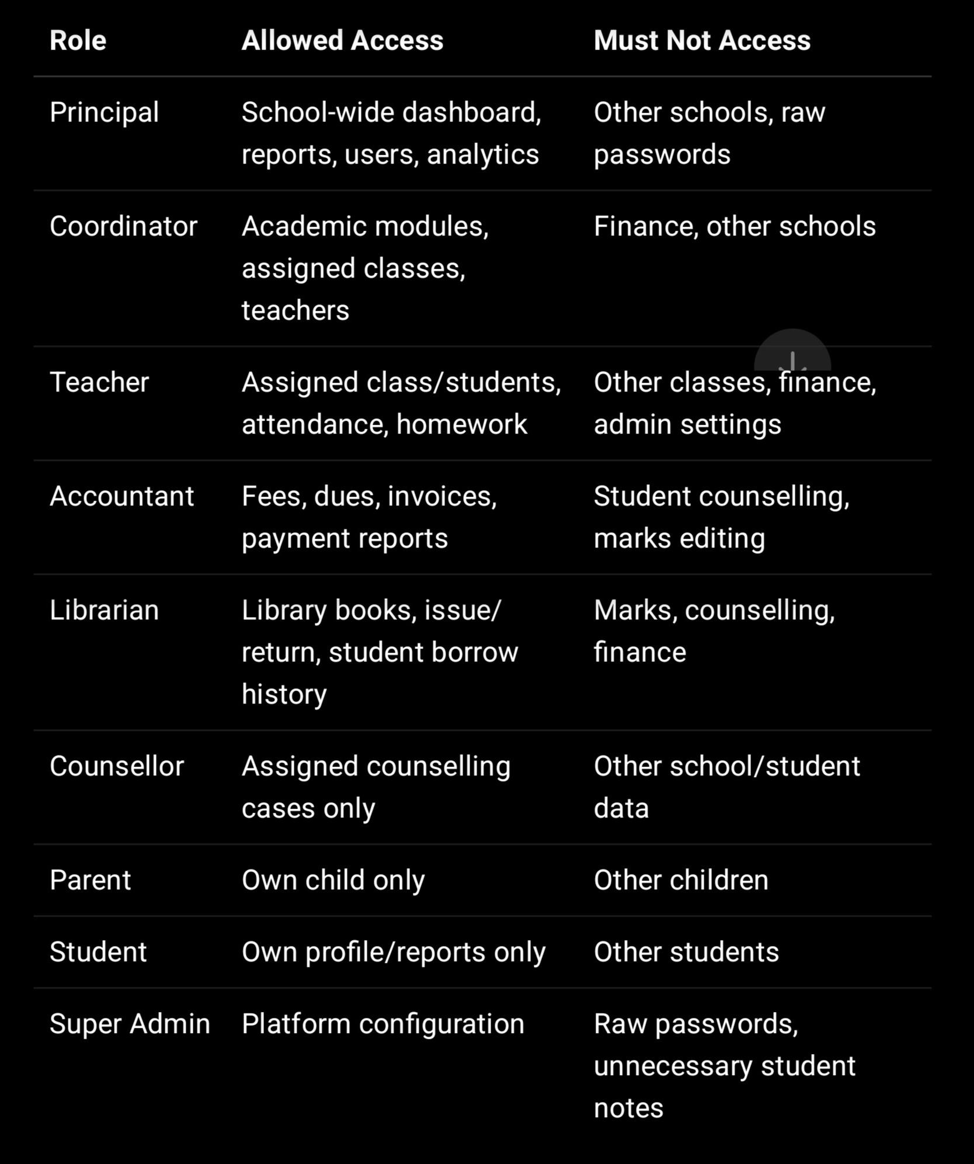

---

5. Backend Middleware Chain

Every protected route should follow this pattern:

router.get(
"/students/:id",
authenticate,
ensureTrialActive,
authorizeModule("STUDENTS", "READ"),
scopeToSchool,
validateObjectId("id"),
enforceStudentObjectAccess,
getStudent
);

---

A. Authentication middleware

async function authenticate(req, res, next) {
try {
const token =
req.cookies?.accessToken ||
req.headers.authorization?.replace("Bearer ", "");

if (!token) {
return res.status(401).json({ code: "NO_TOKEN" });
}

const payload = jwt.verify(token, process.env.JWT_SECRET);

const user = await User.findById(payload.userId)
.select("+tokenVersion +passwordHash");

if (!user || user.status !== "ACTIVE") {
return res.status(401).json({ code: "USER_INACTIVE" });
}

if (payload.tokenVersion !== user.tokenVersion) {
return res.status(401).json({ code: "TOKEN_INVALIDATED" });
}

req.user = {
id: user._id,
schoolId: user.schoolId,
trialId: user.trialId,
role: user.role,
accountType: user.accountType,
trialExpiresAt: user.trialExpiresAt
};

next();
} catch (error) {
return res.status(401).json({ code: "INVALID_TOKEN" });
}
}

---

B. Trial active middleware

async function ensureTrialActive(req, res, next) {
if (req.user.accountType !== "TRIAL") {
return next();
}

if (!req.user.trialId || !req.user.trialExpiresAt) {
return res.status(403).json({
code: "TRIAL_NOT_FOUND",
message: "Trial access is not configured."
});
}

if (new Date(req.user.trialExpiresAt) < new Date()) {
await User.updateOne(
{ _id: req.user.id },
{
$set: { status: "EXPIRED" },
$inc: { tokenVersion: 1 }
}
);

return res.status(403).json({
code: "TRIAL_EXPIRED",
message: "Your trial access has expired."
});
}

const trial = await SchoolTrial.findOne({
_id: req.user.trialId,
schoolId: req.user.schoolId,
status: "ACTIVE",
endDate: { $gte: new Date() }
});

if (!trial) {
return res.status(403).json({
code: "TRIAL_INACTIVE",
message: "Trial is not active."
});
}

req.trial = trial;
next();
}

---

C. Module access middleware

function requireEnabledModule(moduleKey) {
return (req, res, next) => {
if (req.user.accountType !== "TRIAL") {
return next();
}

if (!req.trial.enabledModules.includes(moduleKey)) {
return res.status(403).json({
code: "MODULE_NOT_ENABLED",
message: "This module is not enabled for your trial."
});
}

next();
};
}

Example:

router.get(
"/ai-reports",
authenticate,
ensureTrialActive,
requireEnabledModule("AI_TOOLS"),
authorizeModule("AI_REPORTS", "READ"),
getAiReports
);

---

D. Role permission middleware

async function authorizeModule(module, action) {
return async (req, res, next) => {
const permission = await RolePermission.findOne({
role: req.user.role,
module,
actions: action
});

if (!permission) {
await AuditLog.create({
actorId: req.user.id,
actorRole: req.user.role,
schoolId: req.user.schoolId,
module,
action,
result: "denied",
reason: "ROLE_PERMISSION_DENIED",
ipAddress: req.ip,
userAgent: req.headers["user-agent"]
});

return res.status(403).json({
code: "FORBIDDEN",
message: "You do not have permission for this action."
});
}

req.permission = permission;
next();
};
}

---

E. School scope middleware

function buildSchoolFilter(req, extra = {}) {
return {
schoolId: req.user.schoolId,
isDeleted: { $ne: true },
...extra
};
}

Bad:

await Student.findById(req.params.id);

Good:

await Student.findOne({
_id: req.params.id,
schoolId: req.user.schoolId,
isDeleted: { $ne: true }
});

---

6. Trial Provisioning API

The frontend should call backend API instead of creating users locally.

A. Provision trial request

router.post(
"/trial-provisioning",
authenticate,
authorizeModule("TRIAL_PROVISIONING", "CREATE"),
validateTrialProvisioning,
createTrialProvisioning
);

---

B. Validation schema

const { z } = require("zod");

const trialProvisioningSchema = z.object({
schoolId: z.string().regex(/^[a-f\d]{24}$/i),

enabledModules: z.array(
z.enum([
"ACADEMIC_LEARNING",
"TEACHER_STAFF",
"PARENT_STUDENT_ENGAGEMENT",
"ERP_OPERATIONS_ADMIN",
"AI_TOOLS",
"ANALYTICS_REPORTS"
])
).min(1),

durationDays: z.enum(["3", "7", "14"]).transform(Number),

roles: z.array(z.object({
role: z.enum([
"PRINCIPAL",
"COORDINATOR",
"TEACHER",
"ACCOUNTANT",
"LIBRARIAN"
]),
approvedTrialSeats: z.number().int().min(0).max(5),
assigneeEmails: z.array(z.string().email()).optional()
}))
});

---

C. Backend provision function

const bcrypt = require("bcryptjs");
const crypto = require("crypto");

function generateTemporaryPassword() {
return crypto.randomBytes(12).toString("base64url") + "@1";
}

async function createTrialProvisioning(req, res) {
const payload = req.validatedBody;

const school = await School.findOne({
_id: payload.schoolId,
isDeleted: { $ne: true }
});

if (!school) {
return res.status(404).json({ code: "SCHOOL_NOT_FOUND" });
}

const startDate = new Date();
const endDate = new Date();
endDate.setDate(endDate.getDate() + payload.durationDays);
endDate.setHours(23, 59, 59, 999);

const trial = await SchoolTrial.create({
schoolId: school._id,
status: "ACTIVE",
enabledModules: payload.enabledModules,
startDate,
endDate,
durationDays: payload.durationDays,
createdBy: req.user.id
});

const createdAccounts = [];

for (const roleReq of payload.roles) {
await TrialRoleAllocation.create({
trialId: trial._id,
schoolId: school._id,
role: roleReq.role,
requestedSeats: roleReq.approvedTrialSeats,
approvedTrialSeats: roleReq.approvedTrialSeats,
usedSeats: roleReq.approvedTrialSeats,
createdBy: req.user.id
});

for (let i = 0; i < roleReq.approvedTrialSeats; i++) {
const email =
roleReq.assigneeEmails?.[i] ||
`${roleReq.role.toLowerCase()}${i + 1}@${school.slug}.trial.sproutsong.com`;

const temporaryPassword = generateTemporaryPassword();
const passwordHash = await bcrypt.hash(temporaryPassword, 12);

const user = await User.create({
schoolId: school._id,
trialId: trial._id,
email,
passwordHash,
role: roleReq.role,
accountType: "TRIAL",
status: "ACTIVE",
trialExpiresAt: endDate,
passwordUpdatedAt: new Date(),
createdBy: req.user.id
});

createdAccounts.push({
userId: user._id,
email,
role: user.role,
temporaryPassword
});
}
}

await AuditLog.create({
actorId: req.user.id,
actorRole: req.user.role,
schoolId: school._id,
module: "trial_provisioning",
action: "CREATE_TRIAL",
result: "allowed",
recordType: "SchoolTrial",
recordId: trial._id,
ipAddress: req.ip,
userAgent: req.headers["user-agent"],
metadata: {
enabledModules: payload.enabledModules,
durationDays: payload.durationDays,
accountsCreated: createdAccounts.length
}
});

return res.status(201).json({
success: true,
trialId: trial._id,
startDate,
endDate,
accounts: createdAccounts
});
}

Important: the temporary password should be shown only once or emailed securely. Do not store it.

---

7. Expiry Enforcement

Scheduled job

const cron = require("node-cron");

cron.schedule("0 * * * *", async () => {
const now = new Date();

const expiredTrials = await SchoolTrial.find({
status: "ACTIVE",
endDate: { $lt: now }
});

for (const trial of expiredTrials) {
await SchoolTrial.updateOne(
{ _id: trial._id },
{ $set: { status: "EXPIRED" } }
);

await User.updateMany(
{
trialId: trial._id,
accountType: "TRIAL",
status: "ACTIVE"
},
{
$set: { status: "EXPIRED" },
$inc: { tokenVersion: 1 }
}
);

await AuditLog.create({
schoolId: trial.schoolId,
module: "trial_provisioning",
action: "TRIAL_AUTO_EXPIRED",
result: "allowed",
recordType: "SchoolTrial",
recordId: trial._id,
createdAt: new Date()
});
}
});

Why both cron and login check are needed

Cron expires users automatically.
Login middleware blocks access even if cron fails.
Token version invalidates already-issued sessions.

This gives strong protection.

---

8. Manual Termination API

router.patch(
"/trial-accounts/:userId/terminate",
authenticate,
authorizeModule("TRIAL_PROVISIONING", "UPDATE"),
validateObjectId("userId"),
terminateTrialAccount
);

async function terminateTrialAccount(req, res) {
const user = await User.findOne({
_id: req.params.userId,
accountType: "TRIAL"
});

if (!user) {
return res.status(404).json({ code: "TRIAL_USER_NOT_FOUND" });
}

await User.updateOne(
{ _id: user._id },
{
$set: {
status: "TERMINATED",
terminatedAt: new Date(),
terminatedBy: req.user.id
},
$inc: { tokenVersion: 1 }
}
);

await AuditLog.create({
actorId: req.user.id,
actorRole: req.user.role,
schoolId: user.schoolId,
module: "trial_provisioning",
action: "TERMINATE_TRIAL_ACCOUNT",
result: "allowed",
recordType: "User",
recordId: user._id,
ipAddress: req.ip,
userAgent: req.headers["user-agent"]
});

return res.json({
success: true,
message: "Trial account terminated."
});
}

---

9. Module-Level API Protection

Example for attendance:

router.get(
"/attendance/class/:classId",
authenticate,
ensureTrialActive,
requireEnabledModule("ERP_OPERATIONS_ADMIN"),
authorizeModule("ATTENDANCE", "READ"),
validateObjectId("classId"),
async (req, res) => {
const records = await Attendance.find({
schoolId: req.user.schoolId,
classId: req.params.classId
});

res.json({ success: true, data: records });
}
);

Example for AI:

router.post(
"/ai-reports/generate",
authenticate,
ensureTrialActive,
requireEnabledModule("AI_TOOLS"),
authorizeModule("AI_REPORTS", "CREATE"),
verifyAiConsent,
generateAiReport
);

Example for accounting:

router.get(
"/fees",
authenticate,
ensureTrialActive,
requireEnabledModule("ERP_OPERATIONS_ADMIN"),
authorizeModule("FEES", "READ"),
async (req, res) => {
const fees = await Fee.find({
schoolId: req.user.schoolId
});

res.json({ success: true, data: fees });
}
);

---

10. Frontend Changes Required

Your current frontend can remain similar, but it should not create real accounts locally.

Replace frontend provision() logic

Currently:

state.accounts.push({
role:r.role,
email,
password:state.passwords[r.role],
status:'active'
});

Replace with API call:

async function provision() {
const payload = {
schoolId: selectedSchoolId,
enabledModules: getEnabledModules(),
durationDays: Number(document.getElementById("duration").value),
roles: getSelectedRoles()
};

const response = await fetch("/api/v1/admin/trial-provisioning", {
method: "POST",
headers: {
"Content-Type": "application/json"
},
credentials: "include",
body: JSON.stringify(payload)
});

const result = await response.json();

if (!response.ok) {
alert(result.message || "Provisioning failed");
return;
}

renderProvisionedAccounts(result.accounts);
}

—

11. Do Not Show Password Repeatedly

In your current UI, there is a show/hide password button. For production:

Recommended:

Show temporary password only once immediately after creation.
Force password change on first login.
Do not allow admin to reveal old password later.
Allow “reset password” instead.

Schema:

forcePasswordChange: {
type: Boolean,
default: true
}

On first login:

if (user.forcePasswordChange) {
return res.json({
code: "PASSWORD_CHANGE_REQUIRED"
});
}

—

12. Security Checklist for Trial Access

Before considering this secure, implement:

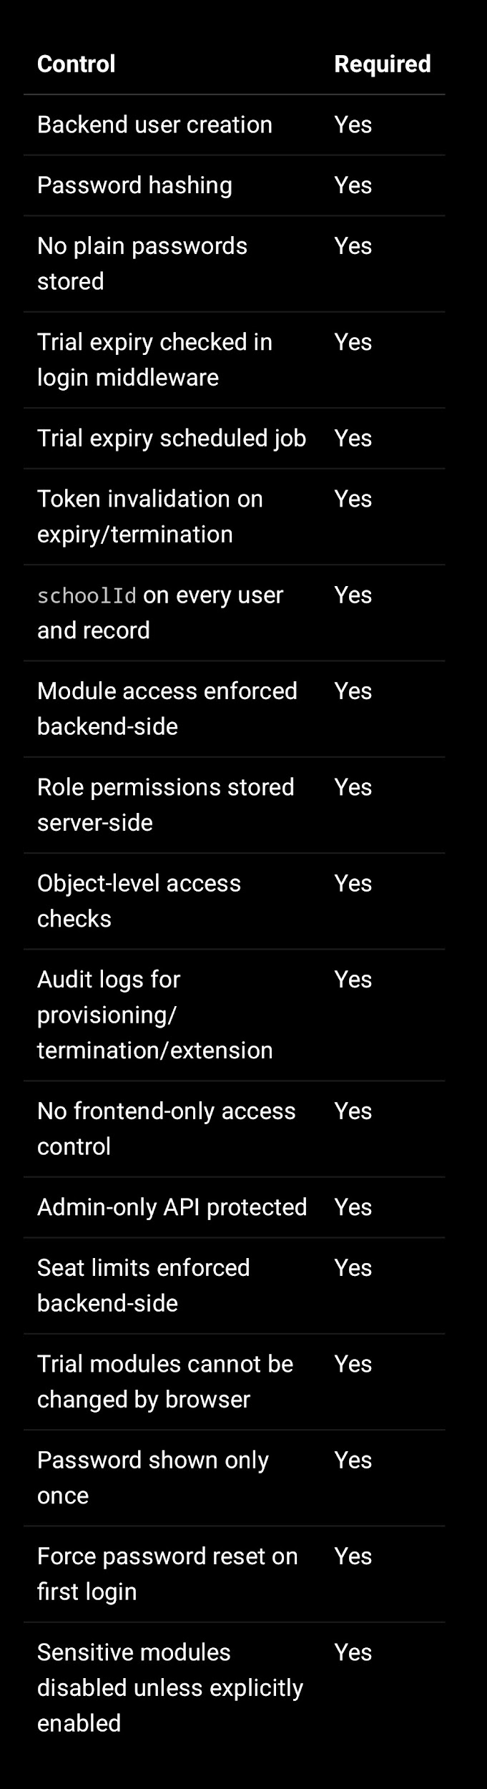
—

13. Specific Problems to Fix from Current File

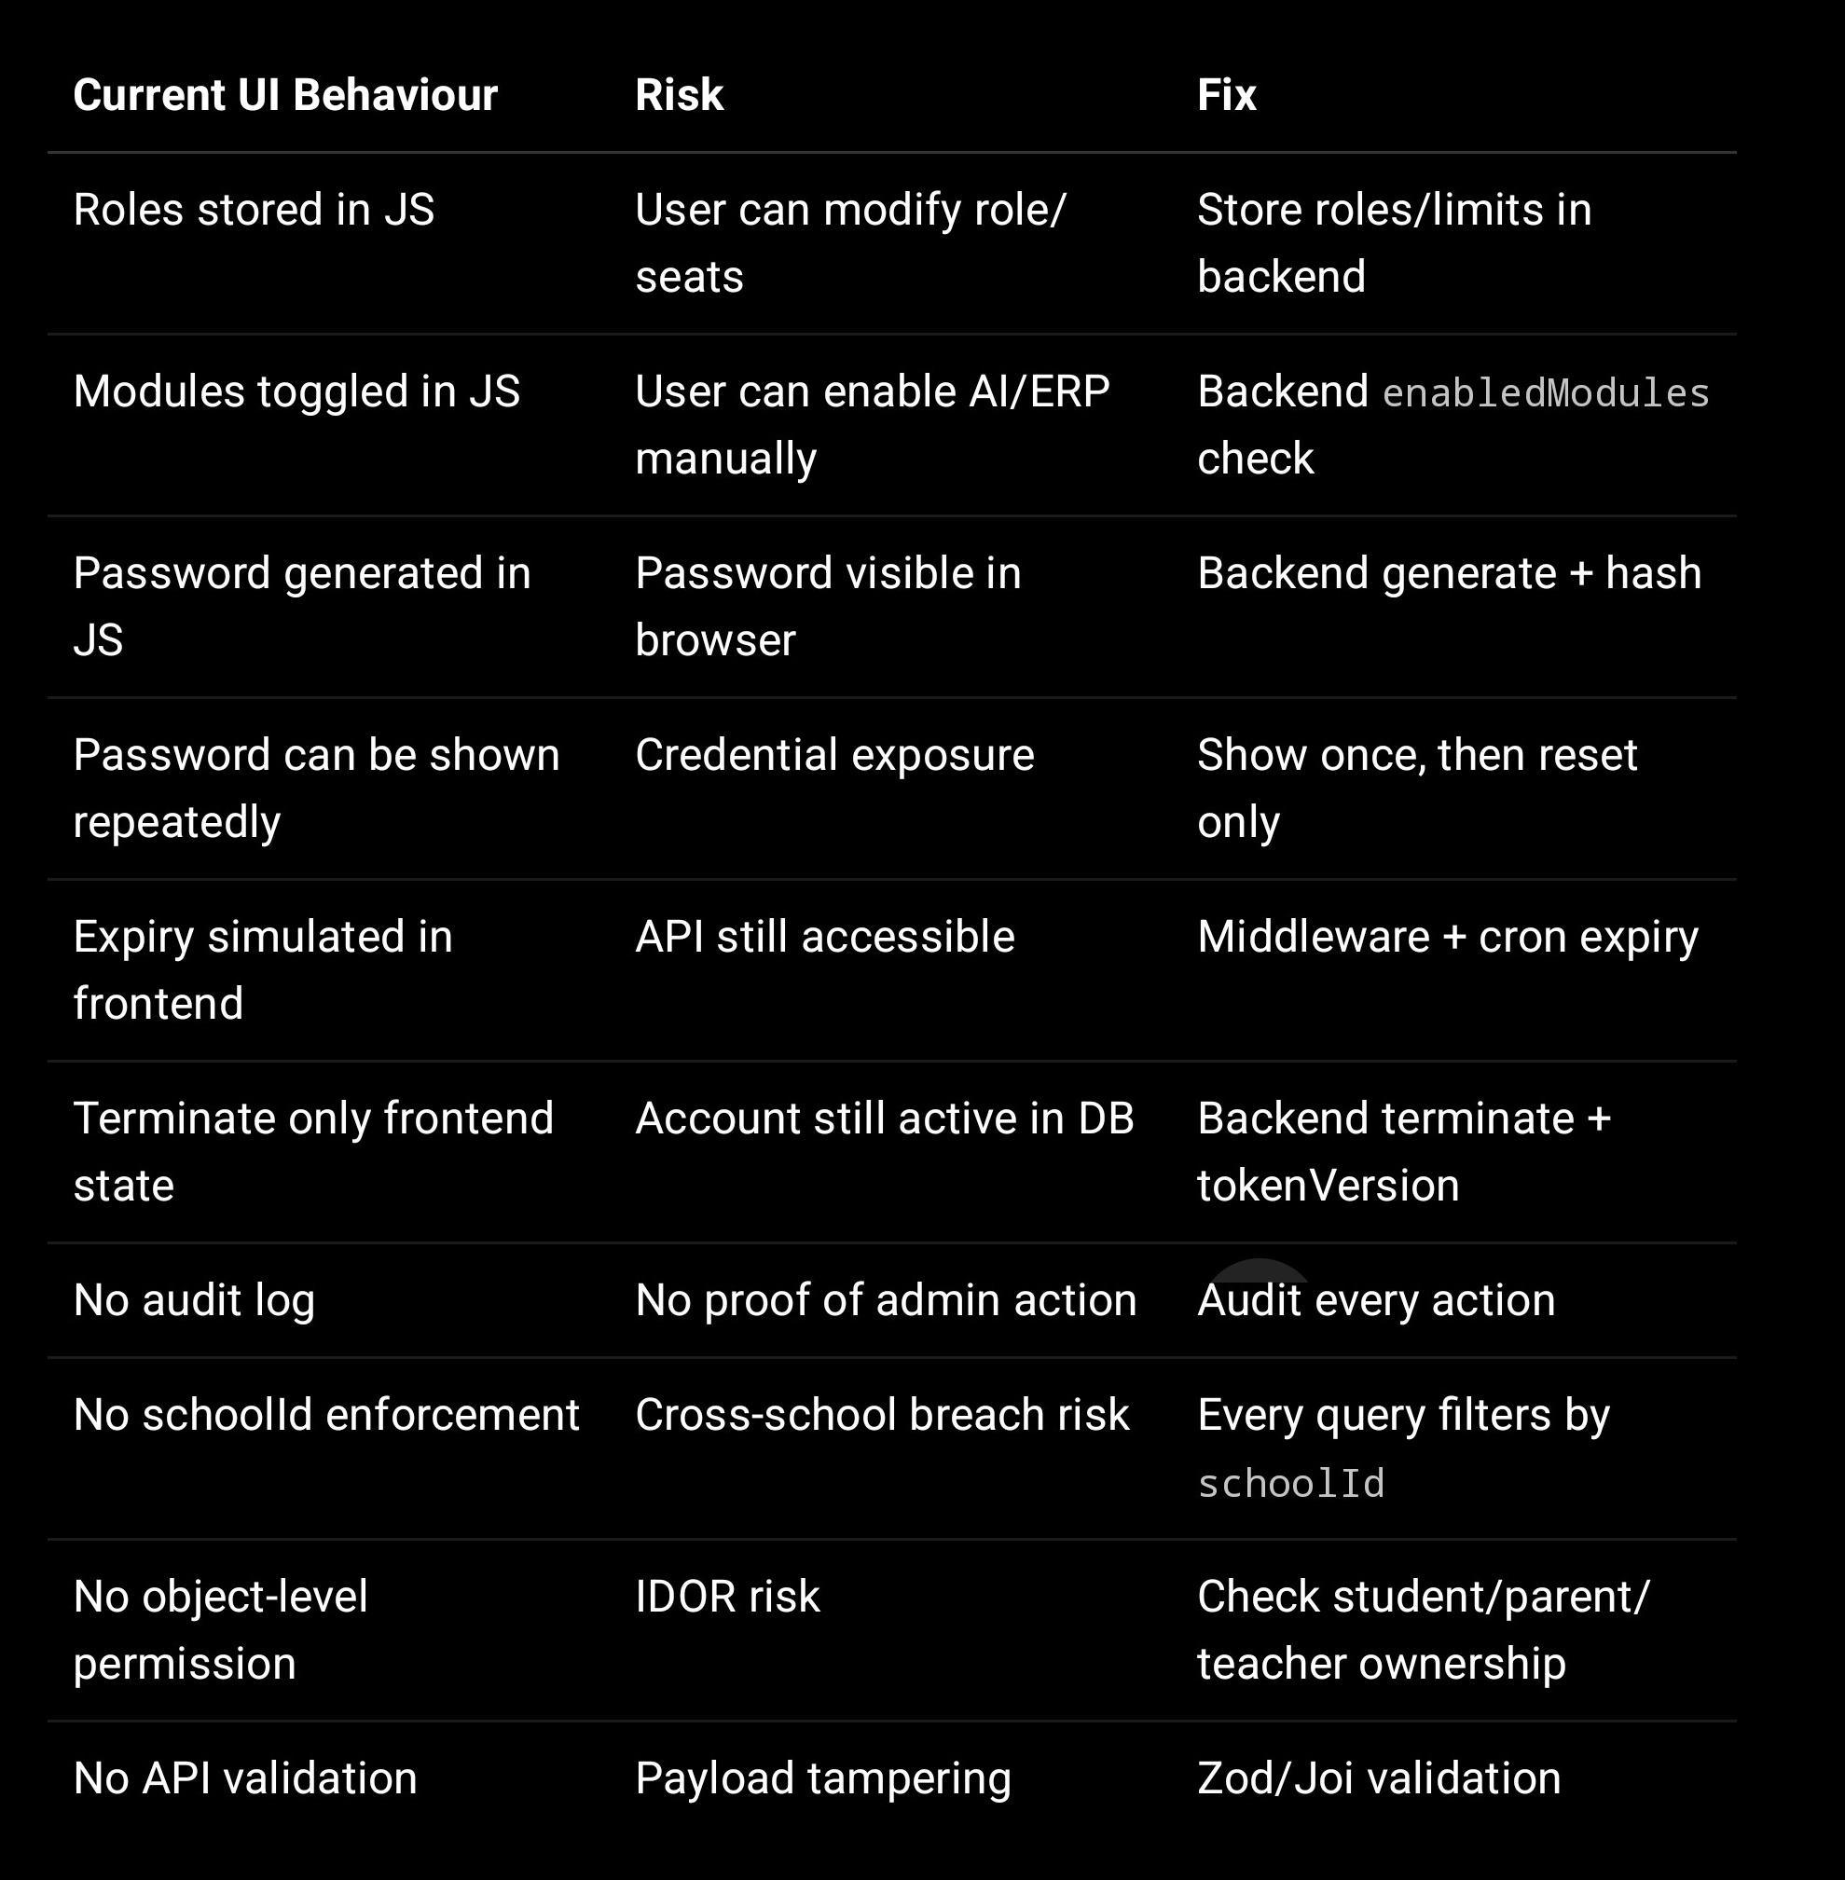

—

14. Recommended Implementation Order

Create SchoolTrial, TrialRoleAllocation, User, RolePermission, and AuditLog backend models.
Create trial provisioning API.
Move password generation to backend.
Add ensureTrialActive middleware.
Add requireEnabledModule middleware.
Add role permission middleware.
Add schoolId filter to all student/teacher/class/report APIs.
Add trial expiry cron job.
Add termination and extension APIs.
Update frontend to call APIs instead of using local state as source of truth.
Remove repeated password reveal.
Add audit trail dashboard for trial access.

—

Final Conclusion

Your interface is a good admin provisioning UI, but it is not a secure role-based access system by itself.

To make it secure, treat frontend as only a display/input layer. The real access control must be enforced by:

Backend authentication
Trial status check
Role permission check
Module enablement check
School-level isolation
Object-level access check
Audit logging
Expiry job
Token invalidation

Once these are implemented, the trial provisioning flow will become much safer for student, teacher, parent, school, and AI/report data access.

